SMART LOCK SYSTEM

Name :- Manan Patel  
D*ept. name of organization :- CHARUSAT UNIVERSITY*   
*City, Country :- Ahmedabad, INDIA*

Email address :- [20it100@charusat.edu.in](mailto:20it100@charusat.edu.in)

Name :- Jay Patel  
D*ept. name of organization :- CHARUSAT UNIVERSITY*   
*City, Country :- Ahmedabad, INDIA*

Email address :- [20it097@charusat.edu.in](mailto:20it097@charusat.edu.in)

Name :- Parth Shah  
D*ept. name of organization :- CHARUSAT UNIVERSITY*   
*City, Country :- Ahmedabad, INDIA*

Email address :- [parthshah.ce@charusat.ac.in](mailto:parthshah.ce@charusat.ac.in)

*Abstract :-* Auto accidents are the leading cause of death of teenage children of age ranging from 14 to 17. When teenage drivers rides the vehicle along with other passengers, their chances of being meet in a fatal car crash increases by 200%. So to overcome this problems we have designed a smart lock system which would prevent teenagers from driving a vehicle . This lock system basically consists of a microcontroller, radio-frequency identification sensor, radio-frequency identification tags and lock. This lock can be the central lock used in cars or the lock used in motor-cycle.

# Introduction

To solve the problem of underage driving and the security of the vehicle, we have designed a very smart lock system This lock system basically consists of a microcontroller, radio-frequency identification sensor, radio-frequency identification tags and lock. This lock can be the central lock used in cars or the lock used in motor-cycle. When this whole circuit is connected to power source like the battery of a car or motorcycle. When the key (RFID Tags) comes in contact with the RFID sensor the lock opens if the key is correct and beep sound comes from the buzzer if the key is incorrect.

# Ease of Use

### How it will help

So, basically a smart lock which can prevent underage teenagers to drive a vehicle they shouldn’t. It would prevent the accidents occurring most frequently.

Reports says that –

Teenagers underestimate or are unable to recognize hazardous driving conditions. 4.4 % of 17 year old drivers and 4.7 % of 18 year old drivers were involved in crashes the highest percentages of any other age group. Also Police data shows that, in last 10 years ( i.e. between 2011 - 2020), a total of 308,000 vehicles were stolen. This is more than the number of vehicles registered in Srinagar on March 31, 2017 according to the police reports. Delhi Police officers say that vehicle thefts constitute about 14% of all the crimes in the city. Even during the first lockdown, which also restricted the movement of people as well as vehicles, about 83 vehicles i.e. more than 3 vehicles in one hour were stolen every day in Delhi from March 15 to March 30 in 2020 and much more.

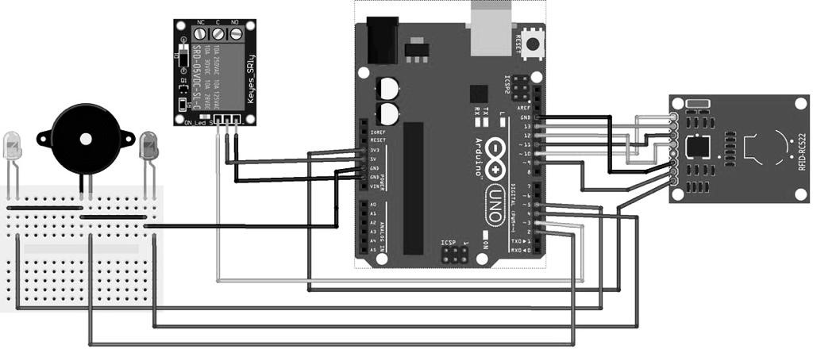

IV Whole Process

The code required for the system to work is written in a simple ‘C’ language. The concept used here is simple if-else loop. Every RFID tag or card consists of an unique UID number like for example “a1 c2 e3 g4”. To compile and upload the code on the arduino circuit the application named Arduino is used. Where we write our code and compile it and upload via cable connected with circuit on our arduino uno board. Then to give access to a particular RFID card or tag we need to open Serial Monitor in the application and scan the particular card or tag where we are able to find that specific UID number. After that we use that UID number in the code we have written. After that to make our system work properly we first need to compile the final code and then upload it on our Arduino Uno board.

III Tools and Technology

1. Arduino Uno circuit.
2. RFID Sensor.
3. RFID Tags/Card.
4. Relay Board.
5. Solenoid Lock.
6. Jumper cables.
7. 9-12 Volt Battery.

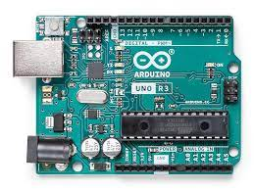

Arduino Uno Circuit.

* Arduino Uno can basically called as a microcontroller board.
* It has 14volt digital input, 6 analog inputs, a USB connection for programming and also for providing power to the circuit, a power jack, and a reset button.
* It contains everything we need to support the microcontroller, we can simply connect it to a computer with a USB cable or power it with a AC to DC adapter or a battery to get started.

RFID Sensor

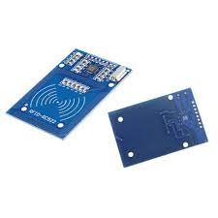

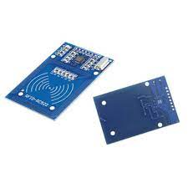

* An RFID Sensor (Radio Frequency Identification Reader) is a device used to access an information from an RFID tag, which here is used as a key.
* It is a wireless identification technology which uses radio waves to transfer data from the card or tag to an RFID reader and identify when the card is in contact with RFID sensor.
* Just like the bar code technology, RFID technology is used to identify objects, persons, by reading the information present or the information that we embed in card.

RFID Tags/Card.

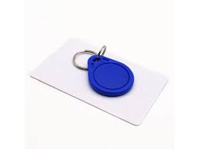

* RFID tags/cards is a type of smart tracking system that uses smart barcode in order to identify or recognise the items.
* The radio waves transmits the data from the RFID tag/card to a reader, which then transmits the embedded information to an RFID computer program that we have designed.

Relay Board.

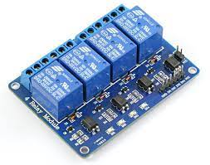

* Relay boards are computer boards with an array of relays and switches. They have input and output terminals and are designed to control the voltage supply.
* Relay boards provides real-time control for each of several onboard relay channels.

Solenoid Lock

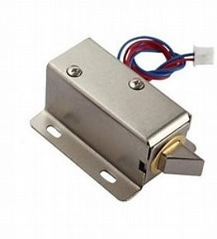

* A solenoid lock is a type of locking mechanism that consists of an electromagnetic device containing a tight wound coil of metal wire called a solenoid which provides the mechanical energy 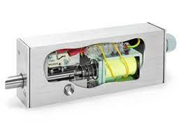that opens and closes the lock.

References:

1. <https://www.homemade-circuits.com/gsm-car-ignition-and-central-lock-using/>
2. <https://create.arduino.cc/projecthub/muhammad-aqib/arduino-rfid-projects-ea3a3b>
3. <https://www.abr.com/what-is-rfid-how-does-rfid-work/>
4. https://circuitdigest.com/microcontroller-projects/arduino-rfid-door-lock-code/#:~:text=Working%20of%20Arduino%20Based%20RFID%20Door%20Lock%20The,transmitting%20the%20data%20to%20the%20RFID%20Reader%20module.